NBKRIST
ELECTROMECHANICAL ENERGY CONVERSION – III
LECTURE NOTES
UNIT-4
I.PRABHAKAR REDDY & E.VINOD ARUN KUMAR
DEPARTMENT OF ELECTRICAL AND ELECTRONICS ENGINEERING

Synchronous Motor - Construction And Working
Synchronous motor and induction motor are the most widely used types of AC motor. Construction of a synchronous motor is similar to an alternator (AC generator). A same synchronous machine can be used as a synchronous motor or as an alternator. Synchronous motors are available in a wide range, generally rated between 150kW to 15MW with speeds ranging from 150 to 1800 rpm.

Construction Of Synchronous Motor

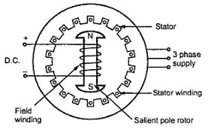
Fig.4.1 Synchronous machine
The construction of a synchronous motor (with salient pole rotor) is as shown in the figure 4.1. Just like any other motor, it consists of a stator and a rotor. The stator core is constructed with thin silicon lamination and insulated by a surface coating, to minimize the eddy current and hysteresis losses. The stator has axial slots inside, in which three phase stator winding is placed. The stator is wound with a three phase winding for a specific number of poles equal to the rotor poles.
The rotor in synchronous motors is mostly of salient pole type. DC supply is given to the rotor winding via slip-rings. The direct current excites the rotor winding and creates electromagnetic poles. In some cases permanent magnets can also be used. The figure 4.1 above illustrates the construction of a synchronous motor very briefly.

Working Of Synchronous Motor
The stator is wound for the similar number of poles as that of rotor, and fed with three phase AC supply. The 3 phase AC supply produces rotating magnetic field in stator. The rotor winding is fed with DC supply which magnetizes the rotor. Consider a two pole synchronous machine as shown in figure 4.2 below.
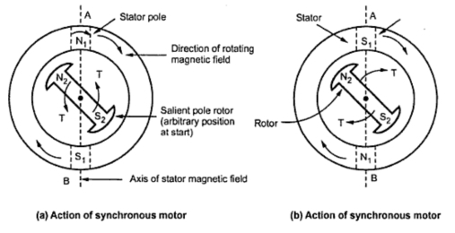
Fig.4.2 synchronous motor working
- Now, the stator poles are revolving with synchronous speed (let’s say clockwise). If the rotor position is such that, N pole of the rotor is near the N pole of the stator (as shown in first schematic of above figure 4.2(a)), then the poles of the stator and rotor will repel each other, and the torque produced will be anticlockwise.
- The stator poles are rotating with synchronous speed, and they rotate around very fast and interchange their position. But at this very soon, rotor cannot rotate with the same angle (due to inertia), and the next position will be likely the second schematic in above figure 4.2(b). In this case, poles of the stator will attract the poles of rotor, and the torque produced will be clockwise.
- Hence, the rotor will undergo to a rapidly reversing torque, and the motor will not start.

But, if the rotor is rotated upto the synchronous speed of the stator by means of an external force (in the direction of revolving field of the stator), and the rotor field is excited near the synchronous speed, the poles of stator will keep attracting the opposite poles of the rotor (as the rotor is also, now, rotating with it and the position of the poles will be similar throughout the cycle). Now, the rotor will undergo unidirectional torque. The opposite poles of the stator and rotor will get locked with each other, and the rotor will rotate at the synchronous speed.

Characteristic Features of a Synchronous Motor
- Synchronous motor will run either at synchronous speed or will not run at all.
- The only way to change its speed is to change its supply frequency. (As Ns = 120f / P)
- Synchronous motors are not self starting. They need some external force to bring them near to the synchronous speed.
- They can operate under any power factor, lagging as well as leading. Hence, synchronous motors can be used for power factor improvement.

Application Of Synchronous Motor
- As synchronous motor is capable of operating under either leading or lagging power factor, it can be used for power factor improvement. A synchronous motor under no-load with leading power factor is connected in power system where static capacitors cannot be used.
- It is used where high power at low speed is required. Such as rolling mills, chippers, mixers,
- Pumps, compressor etc.

Methods of Starting Synchronous Motor
As seen earlier, synchronous motor is not self starting. It is necessary to rotate the rotor at a speed very near to synchronous speed. This is possible by various methods in practice. The various methods to start the synchronous motor are,
1. Using pony motors
2. Using damper winding
3. as a slip ring induction motor
4. Using small d.c. machine coupled to it.
1. Using pony motors
In this method, the rotor is brought to the synchronous speed with the help of some external device like small induction motor. Such an external device is called 'pony motor'.
Once the rotor attains the synchronous speed, the d.c. excitation to the rotor is switched on. Once the synchronism is established pony motor is decoupled. The motor then continues to rotate as synchronous motor.
2. Using Damper Winding
In a synchronous motor, in addition to the normal field winding, the additional winding consisting of copper bars placed in the slots in the pole faces. The bars are short circuited with the help of end rings. Such an additional winding on the rotor is called damper winding. This winding as short circuited, acts as a squirrel cage rotor winding of an induction motor. The schematic representation of such damper winding is shown in the Fig.4.3.
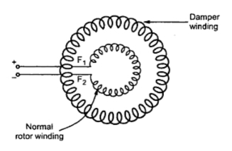
Fig. 4.3 Starting as a squirrel cage I.M.
Once the stator is excited by a three phase supply, the motor starts rotating as an induction motor at sub synchronous speed. Then d.c. supply is given to the field winding. At a particular instant motor gets pulled into synchronism and starts rotating at a synchronous speed. As rotor rotates at synchronous speed, the relative motion between damper winding and the rotating magnetic field is zero. Hence when motor is running as synchronous motor, there cannot be any induced e.m.f. in the damper winding. So damper winding is active only at start, to run the motor as an induction motor at start. Afterwards it is out of the circuit. As damper winding is short circuited and motor gets started as induction motor, it draws high current at start so induction motor starters like star-delta, autotransformer etc. used to start the synchronous motor as an induction motor.
3. as a Slip Ring Induction Motor
The damper winding method of starting of synchronous motor as a squirrel cage induction motor does not provide high starting torque. So to achieve this, instead of shorting the damper winding, it is designed to a form a three phase star or delta connected winding. The three ends of this winding are brought out through slip rings. An external rheostat can be introduced in series with the rotor circuit. So when stator is excited, the motor starts as a slip ring induction motor and due to resistance added in the rotor provides high starting torque. The resistance is then gradually cut off, as motor gathers speed. When motor attains speed near synchronous. d.c. excitation is provided to the rotor, then motors gets pulled into synchronism and starts rotating at synchronous speed. The damper winding is shorted by shorting the slip rings. The initial resistance added in the rotor not only provides high starting torque but also limits high inrush of starting current. Hence it acts as a rotor resistance starter.
The synchronous motor started by this method is called a slip ring induction motor is shown in the Fig.4.4.
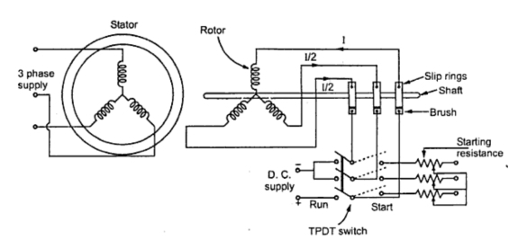
Fig. 4.4 Starting as a slip ring I.M.
It can be observed from the Fig. 4.4 that the same three phase rotor winding acts as a normal rotor winding by shorting two of the phases. From the positive terminal, current 'I' flows in one of the phases, which divides into two other phases at start point as 1/2 through each, when switch is thrown on d.c. supply side.
4. Using Small D.C. Machine
Many times, a large synchronous motor is provided with a coupled d.c. machine. This machine is used as a d.c. motor to rotate the synchronous motor at a synchronous speed. Then the excitation to the rotor is provided. Once motor starts running as a synchronous motor, the same d.c. machine acts as a d.c. generator called exciter. The field of the synchronous motor is then excited by this exciter itself.
Phasor diagram of synchronous motor
Let us write the various notations for each quantity at one place. Here we will use:
    - E_{f} to represent the excitation voltage
    - V_{t} to represent the terminal voltage
    - I_{a} to represent the armature current
    - Θ to represent the angle between terminal voltage and armature current
    - ᴪ to represent the angle between the excitation voltage and armature current
    - δ to represent the angle between the excitation voltage and terminal voltage
    - r_{a} to represent the armature per phase resistance.

Take V_{t} as the reference phasor in order to draw phasor diagram for synchronous motor.
In order to draw the phasor diagram one should know these two important points which are written below:
- We know that if a machine is made to work as an asynchronous motor then direction of a component of armature current will in phase opposition to that of the excitation emf.
- Phasor excitation emf is always behind the phasor terminal voltage.

The phasor diagram for the synchronous motor is given below
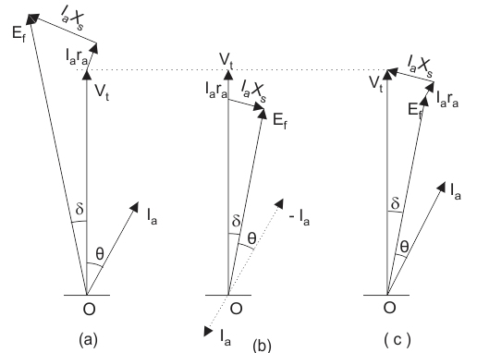
Fig. 4.5 Phasor Diagrams
- Thde fig,4.5(a) shows the phasor diagram of synchronous generator(alternator)/
- In the phasor diagram Fig. 4.5(b), the direction of the armature current is opposite in phase to that of the excitation emf.
- It is usually customary to omit the negative sign of the armature current in the phasor of the synchronous motor, so in the phasor diagram Fig. 4.5(c) omitted the negative sign of the armature current.

- Now we will draw complete phasor diagram for the synchronous motor and also derive expression for the excitation emf in each case.

We have three cases that are written below:

  - Motoring operation at lagging power factor.
  - Motoring operation at unity power factor.
  - Motoring operation at leading power factor.

Given below are the phasor diagrams for all the operations.
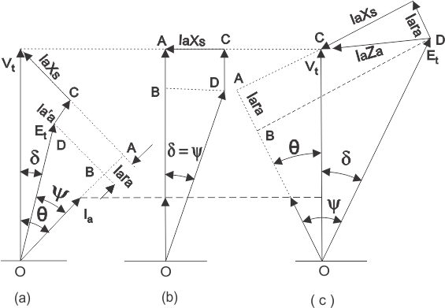
Fig. 4.6 Phasor diagrams of synchronous motor at a) Lagging PF b) UPF
c) Leading PF
(a) Motoring operation at lagging power factor:
In order to derive the expression for the excitation emf for the lagging operation we first take the component of the terminal voltage in the direction of armature current I_{a}. Component in the direction of armature current is V_{t}cosΘ.
As the direction of armature is opposite to that of the terminal voltage therefore voltage drop will be –I_{a}r_{a} hence the total voltage is (V_{t}cosΘ - I_{a}r_{a}) along (in phase) with armature current.
Similarly we can calculate the voltage drop –I_{a}X_{a} along the direction perpendicular to armature current. The total voltage comes out to be (V_{t}sinθ - I_{a}X_{s}) quadrature with I_{a}. From the triangle BOD in the first phasor diagram (Fig. 4.6(a)), we can write the expression for excitation emf as
(b) Motoring operation at unity power factor:
In order to derive the expression for the excitation emf for the unity power factor operation we again first take the component of the terminal voltage in the direction of armature current I_{a}. But here the value of theta is zero and hence we have ᴪ = δ. From the triangle BOD in the second phasor diagram(Fig. 4.6(b)), we can directly write the expression for excitation emf as
(c) Motoring operation at leading power factor:
In order to derive the expression for the excitation emf for the leading power factor operation we again first take the component of the terminal voltage in the direction of armature current I_{a}. Component in the direction of armature current is V_{t}cosΘ. As the direction of armature is opposite to that of the terminal voltage therefore voltage drop will be (–I_{a}r_{a}) hence the total voltage is (V_{t}cosΘ - I_{a}r_{a}) along with the armature current.
Similarly we can calculate the voltage drop along the direction perpendicular to armature current. The total voltage comes out to be (V_{t}sinθ + I_{a}X_{s}). From the triangle BOD in the third phasor diagram(Fig. 4.6(c)), we can write the expression for excitation emf as

Advantages of Drawing Phasor Diagrams for Synchronous Motor
(1) Phasors are highly useful for gaining physical insight into the operation of the synchronous motors.
(2) We can derive mathematical expressions for various quantities easily with the help of phasor diagrams.
V and inverse V curse of Synchronous Motor
A synchronous motor is a double-excited machine; its armature winding is energised from an a.c source and its field winding from d.c source.
When synchronous motor is working at constant applied voltage, the resultant air gap flux demanded by applied voltage remains constant. This resultant air gap flux is established by both a.c in armature winding and d.c in the field winding.
If the field current is sufficient enough to set up the air-gap flux, as demanded by constant applied voltage then magnetizing current or lagging reactive VA required from the a.c source is zero and therefore motor operates at unity power factor.
This field current, which causes unity power factor operation of the synchronous motor, is called normal excitation or normal field current.
If the current less than the normal excitation, i.e the motor is under excited, then the deficiency in flux must be made up by the armature winding m.m.f. In order to do the needful, the armature winding draws a magnetizing current or lagging reactive VA from the a.c source and as a result of it, the motor operates at a lagging power factor.
In case the field current is made more than its normal excitation, i.e the motor is over-excited, operates at leading power factor.

If the armature current is plotted against the field current of a synchronous motor at constant load, the curve appears as V. Hence the curve is known as V curve. The current drawn by the motor will be minimum when the current Ia is in phase with the voltage or the power factor of the motor is unity.
The input power = √3 VI cosф. Thus, if the power factor for constant output is plotted against the field current, at a constant load it will be as inversion of V curve.
The v-curves of synchronous machine motor show how armature current varies with I_{f}, when motor input is kept constant. These curves are obtained by plotting as armature current against dc field current while motor input is kept constant.
The inverted v-curves of synchronization machine motor shows how pf varies with I_{f}, when motor input is kept constant, such that they change with power factor change.

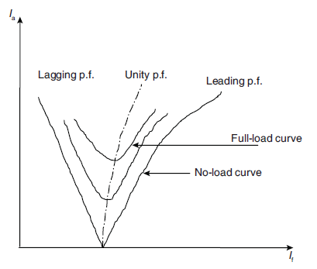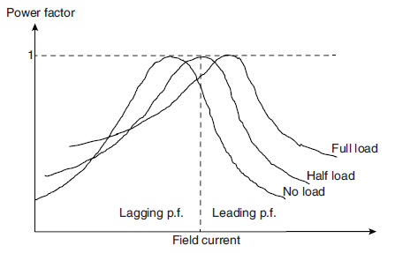

Fig. 4.7 V and inverse V curse of Synchronous Motor

Explanation:
Assume that a synchronous motor is driving a constant torque load. The active power converted by the machine is constant, no matter what the value of the field current is, since the motor speed is a constant. Thus,

Using the phasor diagram below, we analyze the variation of the power factor angle of a synchronous motor when the rotor field excitation is varied.
For a small rotor field current the induced emf in the stator winding is also small, as shown by the phasor Ea1. This yields a lagging power factor angle φ1 > 0.
As the excitation current increases, the lagging power factor angle is reduced. At a certain field current, the induced emf Ea2 is increased and synchronous reactance drop phasor is perpendicular to the terminal voltage phasor, and hence the stator current phasor is aligned with the terminal voltage, that is a zero power factor angle φ2 = 0.
When the field current further increases, the stator current leads the terminal voltage, or a leading power factor angle φ3 < 0.
In the phasor diagram, the above two conditions on Ea and Ia mean that they will only be able to vary along the horizontal and the vertical dotted lines, respectively, as shown below.

Synchronous condenser:
In practice, the synchronous motors are often run at no active load as synchronous condensers for the purpose of power factor correction.
The diagram underneath the phasor diagram illustrates schematically the power factor compensation for an inductive load, which is common for factories using large induction motor drives, using a synchronous condenser.
By controlling the rotor excitation current such that the synchronous condenser draws a line current of leading phase angle, whose imaginary component cancels that of the load current, the total line current would have a minimum imaginary component. Therefore, the overall power factor of the inductive load and the synchronous condenser would be close to one and the magnitude of the overall line current would be the minimum.

Hunting in Synchronous Motor
At no-load, the magnetic axis of the stator and rotor coincides as the load angle δ = 0. However, when the motor is loaded, the rotor axis lags the stator axis by an angle δ. If the load is suddenly changed, the rotor will not immediately attain its equilibrium position but pass beyond it producing more torque than required. The rotor will now swing in the opposite direction to reduce the load angle. This periodic swing of the rotor to either side before stopping at the equilibrium position is called Hunting of the rotor.
Causes of Hunting in Synchronous Motor
1. Sudden change in load
2. Sudden change in field current
3. A load containing harmonic torque
4. Fault in supply system.
Effects of Hunting in Synchronous Motor
1. It may lead to loss of synchronism.
2. It produces mechanical stresses.
3. Increases machine loss and causes temperature rise.
4. Causes greater surges in current and power flow.
Reduction of Hunting in Synchronous Motor
i) By using damper winding: Damper winding damps out hunting by producing torque opposite to slip of rotor. The magnitude of damping torque is proportional to the slip speed.
ii) By using Flywheels: By providing large and heavy flywheel to the prime mover, its inertia can be increased, which in turn, helps in maintaining the rotor speed constant.
Application of Synchronous Motor
1. Synchronous motor having no load connected to its shaft is used for power factor improvement.
2. Synchronous motor finds application where operating speed is less and high power is required.
3. As synchronous motor is capable of operating under either leading or lagging power factor, it can be used for power factor improvement. A synchronous motor under no-load with leading power factor is connected in a power system where static capacitors cannot be used.
4. It is used where high power at low speed is required such as rolling mills, chippers, mixers, pumps, pumps, compressors etc.

